Teaching the Constitution – THIRD GRADE

Lifted entirely from US Constitution.net - http://www.usconstitution.net/constkidsK.html (minus ads)

The Basics

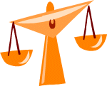
The law is the set of rules that we live by. The Constitution is the highest law. It belongs to the United States.
It belongs to all Americans.
The Constitution says how the government works. It creates the Presidency. It creates the Congress. It creates the Supreme Court.
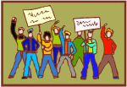
The Constitution lists some key rights. Rights are things that all people have just because they are alive. By listing the rights, they are made special. They are made safe.
The Bill of Rights is a part of the Constitution. The Bill of Rights lists many rights of the people.

History

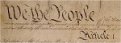
The Constitution was written in 1787. Yes, it is over 200 years old. We actually have old copies of what was created. We have pictures of the Constitution on this site.
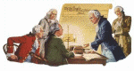
In 1787, a group of men met to write the Constitution. They did not like the way the country was going. They fixed it by creating the Constitution. We call these men The Framers.
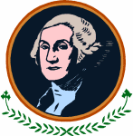
Some of the framers are very famous. George Washington was a Framer. So was Ben Franklin.
The Framers met in Independence Hall during a hot summer in Philadelphia. They had a lot of arguments. In the end, they agreed to the words in the Constitution. They knew they had to agree. If they did not agree, the fighting would keep going.
After the Framers wrote the Constitution, they asked the states to approve it. It took some time, but all the states did approve it.
Some people did not like the Constitution. Some were afraid because it did not do enough to protect the rights of the people. It had no bill, or list, of rights.
Promises were made to add a bill of rights. After the Constitution passed, the Bill of Rights was added. The Bill of Rights is the first ten changes to the Constitution.

The Bill of Rights
The Bill of Rights is very important. It protects important ideas. It protects your right to say what you want. It lets you think for yourself. It keeps the laws from being too hard. It gives rules for the police.
It lets you believe in God if you want. No one can tell you not to believe. It lets you gather with your friends to talk. It makes sure you can read newspapers.
The Bill of Rights also protects your home. It helps keep Americans safe. Today, we are very happy the Bill of Rights was added to the Constitution.

Making changes

The Constitution is not perfect. When it was written, they knew that it would have to be improved. The Framers added a way to make changes. This is called "amendment".
The Bill of Rights was actually added as a set of amendments. The Constitution has been changed 18 times since it was written. The amendments added things that the Framers didn't think of.
One amendment says that all black men can vote. Another says that all women can vote. One more says that the President can only be elected twice.
The first amendments, the Bill of Rights, were added in 1791. The last amendment was added in 1992. Lots of people have ideas for new amendments. Adding an amendment is hard — it takes lots of agreement. Maybe you have a good idea for a change to the Constitution.

How it all works

The Constitution sets up the government. It is split into three parts.
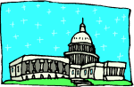
One part is the Congress. The Congress makes laws. The people elect the members of Congress.
The next part is the President. The President enforces the laws.
The last part is the Courts. The courts decide what the law means when there are questions.
All of the parts have to work together. Just like the Framers agreed on the Constitution, the parts have to agree on the laws.

No part has too much power. The power is shared. This helps protect the people.

Not a product of Constitution Translated for Kids, just reprinting a good resource.

