Printed drawings for kids to color Constitution themes

This is a 17 page document, printed in landscape orientation.

US Constitution.net has a number of images for kids to color, inspiring this little collection. But it was multiple printings and varying layouts.

Hopefully, putting it all in a single document is simpler for teachers to handle.

Some images are line drawings from my print book, some are not.

Any drawings not created by me are noted with their copyrights.

CATHY TRAVIS, Author, Constitution Translated for Kids

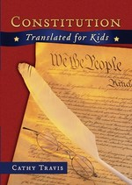

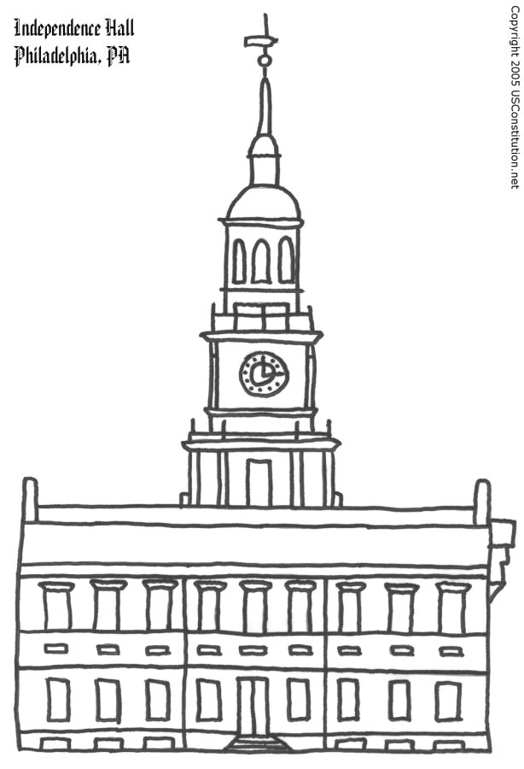
When the founders of the country wrote the Constitution, they gathered at Independence Hall, in Philadelphia, Pennsylvania.
The people who wrote the Constitution wrote it a long time ago – way before phone and computer screens.
The delegates argued and argued over what to put in the Constit-ution. What would you write in there?
In the Constitution, our founders wrote down all the rules they wanted citizens to agree on. It is what we all have in common. Founders wrote the rules by hand, on old timey brown paper.
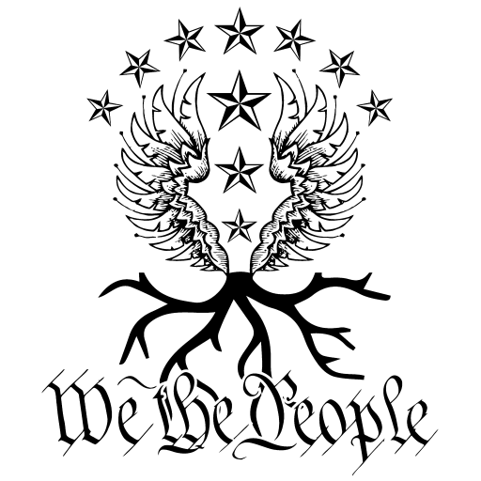
Like the roots of a tree, the Constitution holds the nation steady and keeps us together, whatever branch of the tree we want to sit on.
www.wtpapparel.com
Delegates signed their names with “quills,” a feather dipped in ink. What color would your quill be?

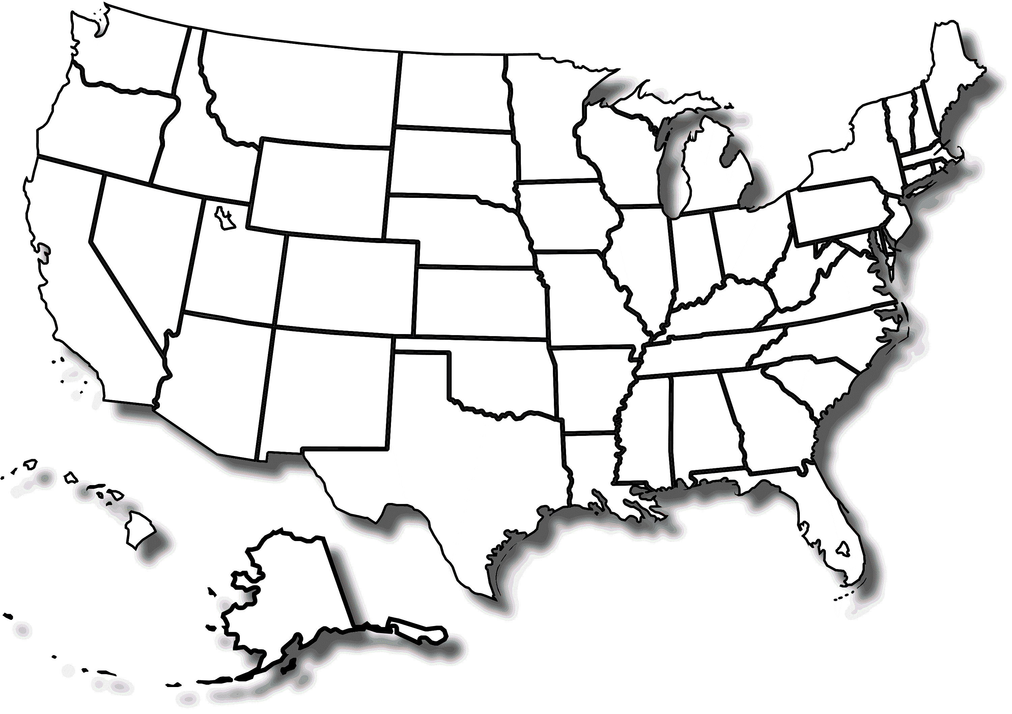 Wikipedia Commons
A map of all the states in the United States of America. Where do you live? What other states have you lived in? Make them a special color.
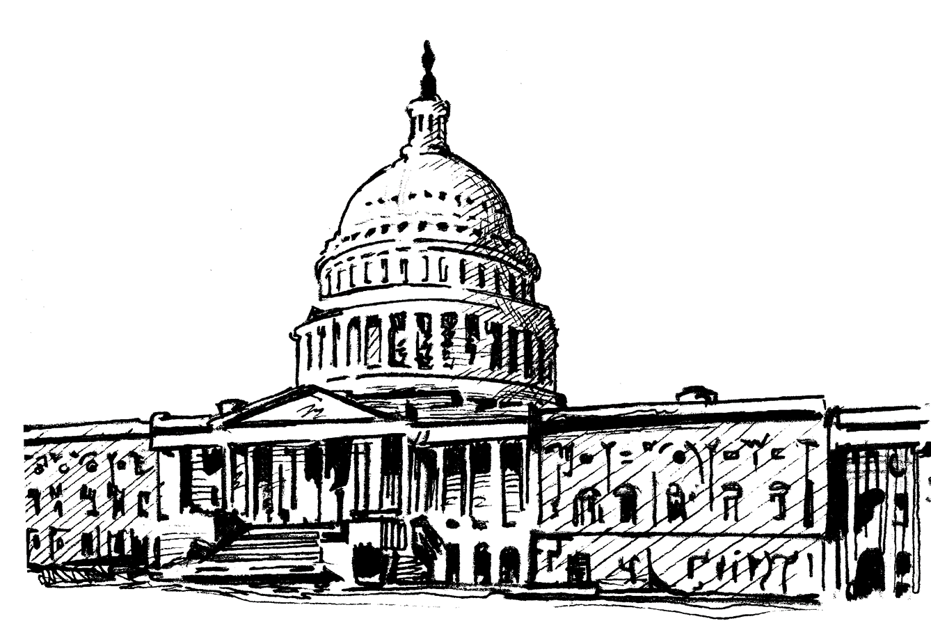
The United States Capitol building in Washington, D.C. This is where Congress makes laws.
The United States Supreme Court building in Washington, D.C. This is where the Supreme Court makes final decisions about laws being constitutional.

The White House – the home and the office of the President of the United States – in Washington, D.C. The president is the one person who is in charge of the country.

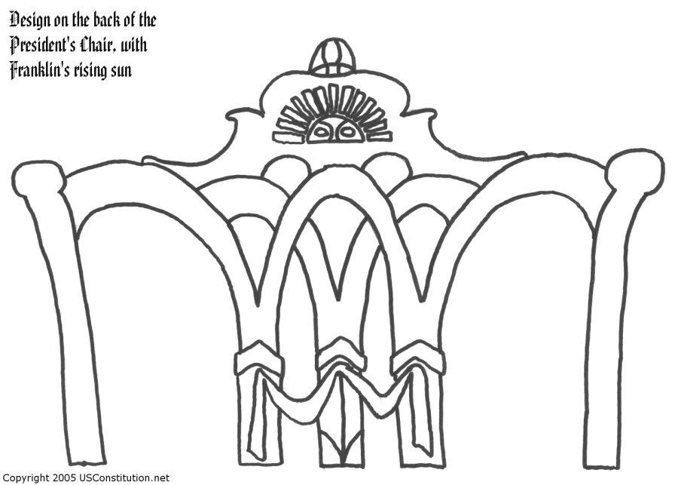

In Independence Hall, the delegates bickered and one of them pointed out a design on the back of Ben Franklin’s chair. It was half of a sun. Was it rising?, they wondered. Or was it setting on their new republic? They decided it was rising, and found agreement in the Constitution.

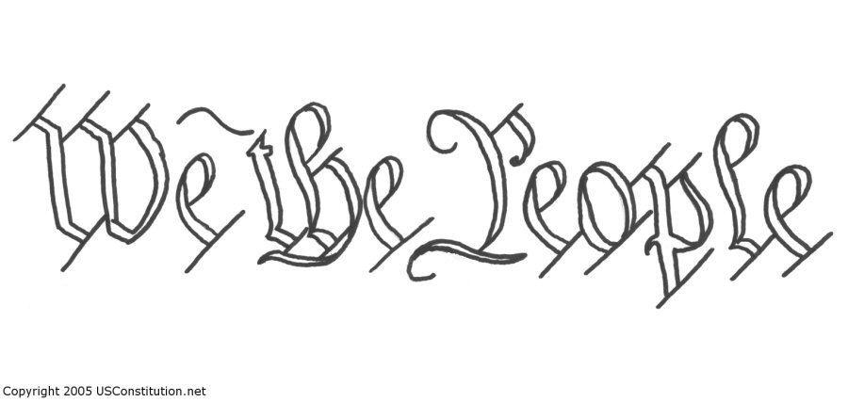

The first three words of the Constitution lay out the shared journey of everybody in the country. Everybody.
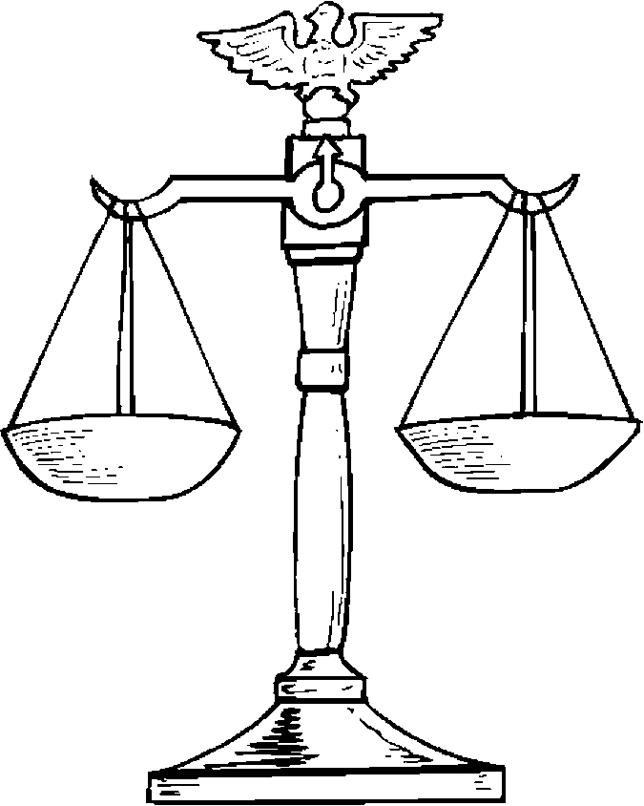 http://www.getcoloringpages.com
Called the “scales of justice,” this shows the equality between people and a balance of government and individual rights.

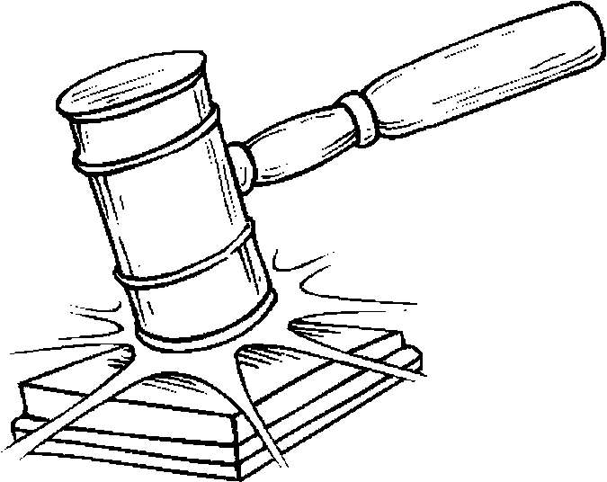
In courts, and in Congress, people indicate a formal ruling by banging a big hammer, called a gavel.

http://www.getcoloringpages.com
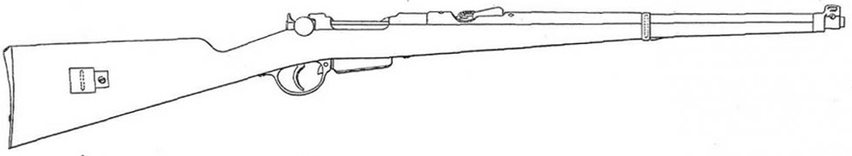
When the Second Amendment was passed (for gun rights to militias) the guns were “muskets” and could only fire one shot at a time. Reloading meant adding gunpowder to the flint, and stuffing a little ball down into the gun barrel.
Wikipedia Commons

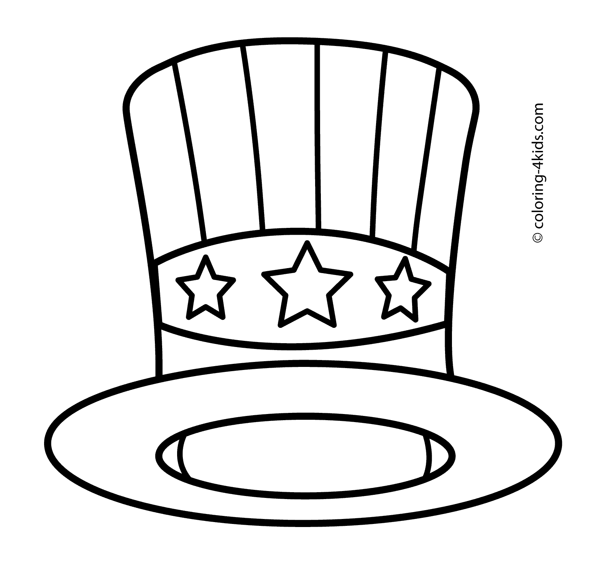
Sometimes people wear funny red, white and blue hats to celebrate the country’s birthday.

